Name: __________________________________ Date: _________
The Gupta Empire Mrs. Valdes

- Read the following passage and answer the questions that follow:

In 320 A.D., a new ruling family, the Gupta, emerged in northeastern India and united the territory around the Ganges River. The Guptas encouraged peace, prosperity, and trade. Gupta emperors built universities and supported learning, the arts, and literature. Hindu scholars excelled at the sciences. Hindu mathematicians developed the concept of zero, the idea of infinity, and a decimal system. Artists painted colorful murals, while writers composed poems and plays in Sanskrit (the literary and religious written language of India). Because the Guptas were Hindus, the two centuries of Gupta rule are sometimes referred to as the Golden Age of Hindu Culture.

Questions:

- Where and when did the Gupta Empire develop?
In 320 A.D., Northeastern India and united the territory around the Ganges River
- Why is the Gupta period considered a golden age of Hindu culture?
The Guptas encouraged peace, prosperity, and trade. Gupta emperors built universities and supported learning, the arts, and literature. Hindu scholars excelled at the sciences.
- List three accomplishments of Hindu mathematicians.
Hindu mathematicians developed the concept of zero, the idea of infinity, and a decimal system.
- What artistic achievements occurred during the Gupta Empire?
Artists painted colorful murals
- A classical civilization is a civilization that contributed important ideas and inventions to world history. Why is the Gupta Empire a classical civilization?

Golden Age (classical civilization) because they gave us mathematics, science, art, and literature.

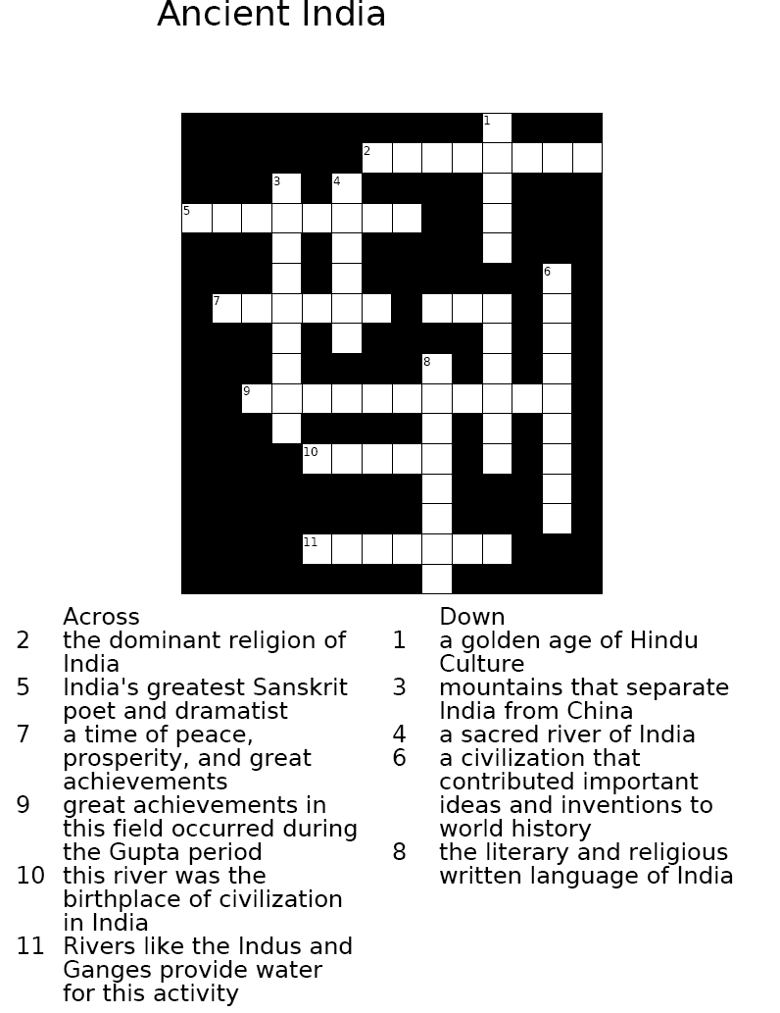

Word Bank:
Ganges, Farming, Indus, Mathematics, Golden Age, Kalidasa, Gupta, Hinduism, Himalayas, Classical, Sanskrit

***Working With Documents:

 | Maurya | Gupta
Dates | 321 B.C.–185 B.C. | A.D. 320–550
Location | Northern and southern India | Northern India
Government | - Harsh rule  - Organized government  - Officials collect taxes  - Government- owned factories | - Mild rule  - Organized government  - Villages and cities had power
Learning | - Schools and libraries in capital  - Missionaries spread Buddhism | - Golden age of learning  - Number system we use today, decimal system, concept of zero  - Plastic surgery, vaccines for smallpox  - Carvings of gods and animals

- Using the document, what contributions were made in math and science during the Gupta Empire?
Plastic surgery, vaccines for smallpox
Number system we use today, decimal system, concept of zero

According to the document, what differences existed between Mauryan rule (government) and Gupta rule?
Mauryan- harsh rule
Gupta-mild rule

